**Railway Reservation System**

**Saptarshi Acharya 22BCE1134**

**Rishabh Shital Ramdhave 22BCE1824**

**Abhishek Kumar Singh 22BCE1867**

**Course Faculty**

**Dr. Ilakiyaselvan N**

**School of Computer Science and Engineering**

**VIT Chennai**

**Chennai-600127, India**

**Abstract**

The goal of the railway reservation system project is ordering managing and cancellation of train tickets. These tasks can be completed by users from the comfort of their homes with minimal effort and the saving a lot of time. It is a dependable with an affordable solution, utilizing minimal system requirements and providing a straightforward user-friendly interface. The system incorporates a Tinker developed GUI and my SQL management system to provide a safe and effective booking process.

The main objective of this project is to provide very less latency better user interface and experience without compromising on the efficacy of the database management system, thus, using the technologies involving Python and SQL, the system designed is tested and proves to be an efficient solution to the target problem

**Keywords**

**Railway Reservation System, Online Ticket Booking, Tkinter, MySQL, Python, GUI, Database Management, Ticket Cancellation, Passenger Records, Cost-effective**

**Introduction**

The railway reservation system addresses the issue of convenience while booking and cancelling railway tickets. Traditional ticketing processes involve long wait times at physical counters and a lot of paperwork, but our system offers a modern solution. This project uses python’s Tkinter library to provide an intuitive GUI as well as my SQL to manage the bank in database. The result of this is an easy-to-use accessible system that allows users to manage their reservations or check their waiting list with just a few clicks.

**Literature Review**

1. **Railway Online Booking System Design and Implementation**

This project contains an entity relationship model diagram upon which a railway reservation system has been based. The aim of this study is to design and develop a database which maintains records of the train status, passenger records and railway reservations. It is a computerized system, making the reservation of seeds much easier than ever before. It enables the user to enquire about trains based on the source and destination. It enables the booking and cancellation of tickets enquiry about the status of the book tickets and tracking the current position. This project is an implementation based on a relational model.

1. **Design of an electronic railway ticket reservation system for rift valley railways**

This project enables a convenient quick reservation of railway tickets by passengers electronically where they can do this at the convenience of their own time and their place wherever there is an internet connection. The need for this project increased due to the manifold increase in the passenger travelling by trains. Computerization of system has enabled users to work on many of their previous limitations. This this is now much more efficient and convenient to learn and use system provides users with information about trains – schedules, simplifies, reserving. The ticket reservation for the passengers is fast and executing data at the point of need, efficient error validation, capturing information about the passengers, and providing interfaces with easy navigation throughout the system.

1. **Intelligent Reservation Systems Based on MAS & Data Mining Method**

Project is an intelligent reservation system based on the combination of multiple agent system and data mining techniques which makes intelligent decisions on whether to accept or reject new clients response for reservation needed services. The reservation strategies are developed using integer, aggregate results, database ARD with multi system. It consists of the following agents, client agent, stock agent, station agent, aggregation agent, and agent resp system applies data mining methods in a distributed way. Information requested by the client; the purpose of the proposal is to reduce response time resource consumption by storing responses in ARD.

1. **Modernization of Passenger Reservation System: Indian Railways’ Dilemma**

Seeing the rapid growth in the current times, the Eden railways is concerned with the management systems which are not capable enough to handle the increasing demands and expectations of the customers. It is in a dilemma on whether to use the previous PRS system for preservation, which is time tested and liable and has been serving. The customers need for nearly two decades as it is now proving to be relatively in flexible to my rapidly changing business requirements. De replace the old Piyare with the new state of the Earth system that would provide them greater maintenance flexibility. The replication associated with possible failure of the new system. Part two series, the cases, the current dilemma being faced by the head of CRIS, the umbrella agency for IT implementation in IR, whether AI should continue using the old PRS technology with its inherent shortcomings or should it take the risk and go in a whole going for a wholesale replacement with a new state of art technology, which should provide greater maintenance flexibility?

1. **ONLINE TRAIN TICKETING SYSTEM (CASE STUDY OF MINNA RAILWAY STATION)**

The current railway management system is inundated with problem such as duplications, data, tenancy, as well as stress involved in seat reservation for passengers which often results to errors in computation among others. The new system which is an online application enables passengers to book for the travels from the comfort of their homes, hence required few individuals to manage reservation process of the Corporation tickets. Reservation systems developed using PHP hypertext, pre-processor as service site, scripting, language, JavaScript as client, site, scripting language. A combination of HTML and CSS was used to give system is suitable and user-friendly interface while SQL was used as database to store and manage records.

1. **Concept of a data centralization system for a railway transportation and station management systems**

The paper advocates for the digitization of transportation enterprises focusing primarily on the railway industries need for integrated ticket and asset management systems. It introduces a data technology as a solution in which a centralized data management system and evening railway companies to enhance operational efficiency and improve decision making processes. The paper demonstrates the potential for achieving holistic sites to optimize railway operations by integrating diverse data sources within the data League framework, practical implementation of data leak, exemplifies its efficacy in railway application’s pivotal role in modernizing Railway transportation systems.

1. **Comparative study of ticket booking system**

The main purpose of the study is to identify the ATVM machine uses as ignored facility. Suggestions for prospects of totally eliminated cues are also addressed. The main problem with Indian railway system is the frequent long-standing cues that can be seen at stations to overcome these cues, different methods are used like ATM, automatic ticket, vending machines introduced in such a way that smart cards are linked with them and now at present, it is also linked with the UTS application. This smart card can be purchased and recharge a ticket counter more over. This application is built on android platform, which holds the majority of market. The ticket can be booked using an application soft copy later on COATVM machines per introduced which is an extension of KBM machine which involves payment through notes or coins. Another method involves the use of GPS technology where the user has to enable GPS through the UPS application. Other proposed method is the use of ZigBee and RFI technology linked with the ATM machine. The ticket generated with RFID is to be shown on the doors and doors open automatically close back in sometime.

1. **More than a failure? The computerized reservation systems at French Railways**

Present part of ongoing research into French Railways and the introduction of Socrate, a computerized reservation and ticketing system. SNCF pot Saber from American Airlines in order to build socrate Pam P. One of its aim was to transform commercial activities through the instigation of a new philosophy of selling based on technological investment importing techniques management which is used in the airline industry. This paper are used that support is an integral part of the problematic adoption of a new railway transport model based on the D regulated airline industry.

1. **Online Railway Ticketing System: A Case Study of Kaduna to Abuja Branch of**

**Nigerian Railway Corporation**

The aim of the study is to develop software which computerize the process of acquiring travel ticket at the Nigerian Railway Corporation. The software is designed to be web based having both front and backend front and was built using user interface, development framework, boot, faces, prime, faces, and facelift, the backend was configured with my school server. Java programming language was used to write the underlying codes for communicating between the front and the backend. The study involves a document review and interview which were used as the method of data collection. What a model was used as the software development model data collected work, analyse to design the proposed system and functional software was developed. The software developers tested with sufficient test data and was found to be accurate and consistent.

1. **A mobile application to enable users to view bus schedules and extend bus booking and reservation services**

This research focused on creating a mobile and web application to enable people access reservation services for the Gagga Bus Company. This was intended to help people avoid wasting that time and plan this journey in advance with no risk of missing a seat in a particular bus. A major problem was a constant mess of buses, travelling to distant places across East Africa due to the poor timing of passengers, the research created the traveler mobile application that would help in solving this problem by providing transport services. The researchers use the waterfall methodology and technique such as data flow diagrams, UML techniques and prototyping to come up with a system requirements upon testing of the system. Researcher use unit testing system, integration, testing and usability testing. Researchers use android as a platform to develop the mobile application and also use web application development tools and languages such as PHP, my skills and query to develop the web application.

**Comparative Analysis**

|  |  |  |  |
| --- | --- | --- | --- |
| **Research Paper** | **Focus** | **Methodology** | **Key Findings** |
| 1. Iqbal et al. | Design and implementation of an online railway booking system | Relational database model | Emphasizes user-friendliness and efficiency. |
| 2. Mugira and Okiror | Design of an electronic railway ticket reservation system | Not explicitly mentioned | Focuses on convenience and accessibility for users. |
| 3. Maamra and Kholladi | Intelligent reservation systems using MAS and data mining | Agent-based approach and data mining | Aims to improve decision-making and resource utilization. |
| 4. Srivastava et al. | Modernization of Indian Railways' passenger reservation system | Case study and analysis | Discusses challenges and opportunities for modernization. |
| 5. Ahmad | Online train ticketing system (case study) | Case study of Minna Railway Station | Examines the implementation of an online ticketing system. |
| 6. Concept of a data centralization system | Data centralization for railway transportation and station management | Discusses the benefits and challenges of data centralization. |  |
| 7. Rathod et al. | Comparative study of ticket booking systems | Comparative analysis of different ticketing systems | Identifies strengths and weaknesses of various approaches. |
| 8. Mitev | Evaluation of computerized reservation systems | Case study of French Railways | Analyzes the challenges and successes of implementing computerized reservation systems. |
| 9. Musa et al. | Online Railway Ticketing System: A Case Study of Kaduna to Abuja Branch | Case study of a specific railway branch | Examines the implementation and impact of an online ticketing system. |
| 10. Akumu | Mobile application for bus schedules and booking | Mobile application development | Focuses on providing mobile access to bus-related services. |

**Proposed work**

Considering the problems described above, we proposed a solution Railway Reservation System. It is a simple desktop application developed by Python, Tkinter, and MySQL Connector. The features within this system allow passengers to book tickets, observe their booking status whether confirmed or waiting, and even cancel tickets without much hassle. The passenger may view the advance status of train availability in order to make a plan. The system is also equipped with an admin interface where administrators can introduce new trains, cancel other exiting trains, and manage the train schedule. All this ensures that passenger and all their train information are kept safely within a relational database, thereby allowing smooth, real-time update and efficient handling of the reservation process.

**Features:**

**User side:**

* Book ticket: user is first asked to enter the date, destination and arrival information. This query is sent to the database to check if trains exists on the provided particular details. The details of all such trains are displayed and user can seamlessly select the preferred train.
* Cancel Ticket: user can also cancel their tickets from the software itself by just entering their PNR and OTP received during booking of the tickets.
* Waiting Ticket: The concept of waiting list has also been used where if a user cancels his ticket the empty seat is allocated to the user next in queue or next in waiting list.
* Check Status: Status of ticket and train can also be viewed from the software itself. It includes ticket confirmed or waiting and train running or cancelled.

**Admin side:**

* Add train: the admin can add train schedule or update the same.
* Cancel train: the admin can cancel a particular due to any reason same is updated on user side on check status screen.

**Scope of the Project**

The following gives an outline of how the program works, when someone books a ticket for boarding a train. The scope of this project is:

* To weigh the pros and cons of the commodity.
* To be able to understand the basic outline of the program.
* To know the requirements of all the source codes and packages required. • To have a basic idea of how it can improve more, and what else can be added for more secure and reliable way of booking tickets while keeping your privacy unendangered.

**Contribution of Project in Real World**

* This project aims at development of an Online Railway Reservation Utility which facilitates the railway customers to manage their reservations online. •
* Getting advantages of booking or cancelling your tickets sitting in the comfort of your home or office.
* One can save the time needed to travel to the railway reservation office and waiting in the queue for your turn.
* Instead of printing your ticket you can also choose to travel with the SMS or soft copy of your booked ticket in your devices.

**Methodology**

TKINTER: Tkinter has been used to create the GUI of our project. Tkinter is the standard GUI library for Python. Python when combined with Tkinter provides a fast and easy way to create GUI applications. Tkinter provides a powerful object-oriented interface to the Tk GUI toolkit.

MYSQL: MySQL is currently the most popular database management system software used for managing the relational

database. It is open-source database software, which is supported by Oracle Company. It is fast, scalable and easy to use database management system in comparison with Microsoft SQL Server and Oracle Database. It is commonly used in conjunction with PHP scripts for creating powerful and dynamic server side or web-based enterprise applications.

MYSQL Connector: MySQL Connector/Python enables Python programs to access MySQL databases, using an API that is compliant with the Python Database API Specification v2.0 (PEP 249). It is written in pure Python and does not have any dependencies except for the Python Standard Library. We have used this module in our project to connect the database of passengers in MySQL with python.

**Final Work**

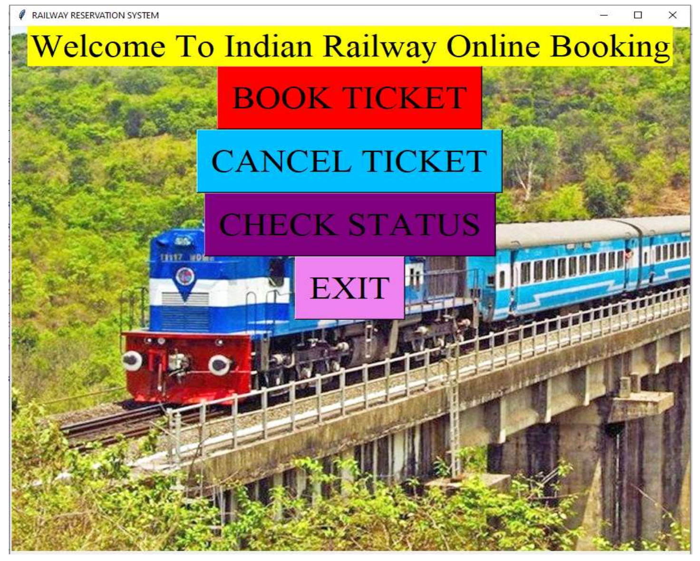

Figure 1: Main Menu

Figure 2: Ticket Booking Window

Figure 3: Payment Window

Figure 4: Ticket Cancellation Window

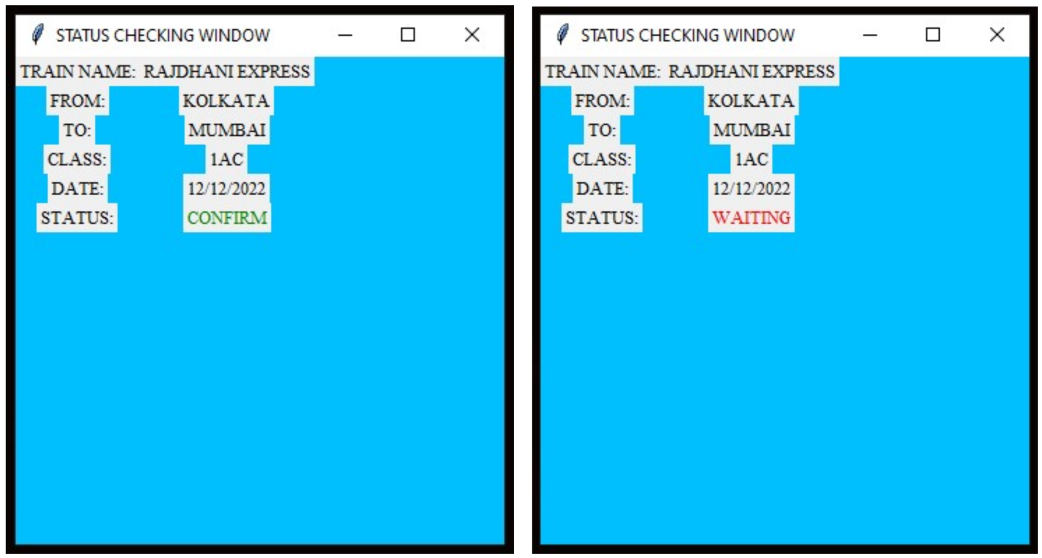

Figure 5: Status Checking Window

**Source Code:**

**<https://github.com/SaptarshiAcharya/RAILWAY_RESERVATION_SYSTEM>**

**References**

1. Iqbal, Md Asik, Tridib Biswas, and Rokebul Ehsan. *Railway Online Booking System Design and Implementation*. Diss. East West University, 2019.
2. Mugira, Richard, and Daniel Okiror. "Design of an electronic railway ticket reservation system for rift valley railways." (2015).
3. Maamra, Oum Elhana, and Mohamed-Khireddine Kholladi. "Intelligent reservation systems based on MAS & data mining method." Advanced Intelligent Systems for Sustainable Development (AI2SD’2018) Volume 5: Advanced Intelligent Systems for Computing Sciences. Springer International Publishing, 2019.
4. Srivastava, Shirish C., Sharat S. Mathur, and Thompson SH Teo. "Modernization of passenger reservation system: Indian Railways’ dilemma." Journal of Information Technology 22.4 (2007): 432-439.
5. AHMAD, JIBRIL. "ONLINE TRAIN TICKETING SYSTEM (CASE STUDY OF MINNA RAILWAY STATION)." (2019).
6. Concept of a data centralization system for a railway transportation and station management systems
7. Rathod, Vikas J., Shital Patil, and Gayatri Shelar. "Comparative study of ticket booking system." (2017).
8. Mitev, Nathalie N. "More than a failure? The computerized reservation systems at French Railways." *Information Technology & People* 9.4 (1996): 8-19.
9. Musa, Abubakar Ahmad, et al. "Online Railway Ticketing System: A Case Study of Kaduna to Abuja Branch of Nigerian Railway Corporation."
10. Akumu, Mary. "A mobile application to enable users to view bus schedules and extend bus booking and reservation services." (2013).